Mockup screen for 3rd party / Own Service Provider Tab
1) Grid will show all assigned third party or own party to the claim.
2) After clicking of Add new Party,
3) User first will select Claim type ( Own Damage , PD or BI)
4) Then system will ask for service provider type ( own / TP)
2) Then system will ask Party type ( Insurer, Surveyor, Lawyer, Workshop/Depot ).
4) Add party screen will come accordingly to the selection.

Remarks

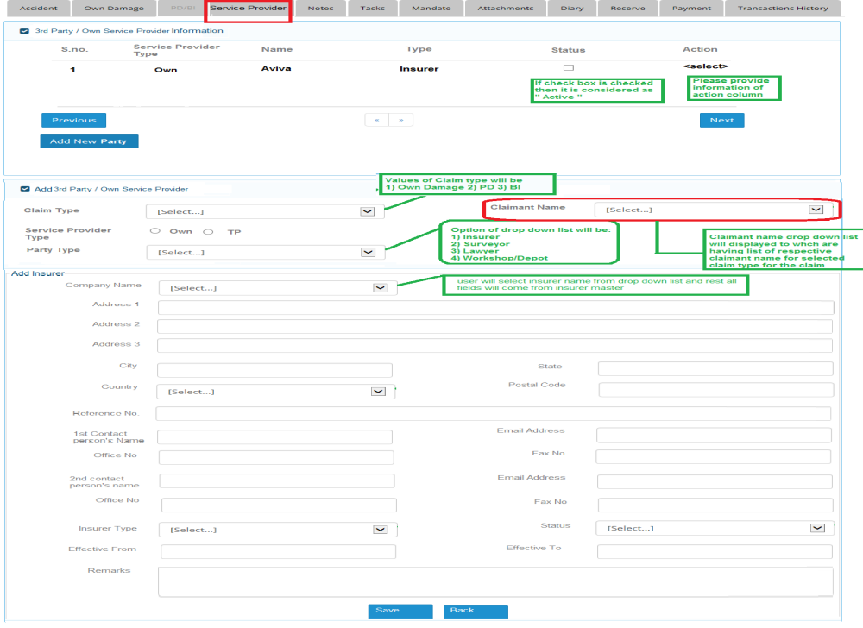
Dexter [24-Sep]: The Own and Third Party Service Providers that are created are to be attached to the relevant Third Party Claimant input during the OD / PD / BI Creation. E.g. If Jason is a Third Party Claimant created in a BI Claim and CDGI creates 1 TP Lawyer, 1 TP Workshop, it means that Jason is the one who has engaged these two Service Providers and CDGI are to keep track of their existences during Claim Processes / Reserves / Payments.

Varun comment[24 sep]:
1)One more field for claimant name drop down list has been added which will be displayed based on claim type.
2) If Claim type is PD or Bd then claimant name drop down list will be displayed and which will have respective claimant name. For example : if user selected PD in claim type then claimant name drop down list will be filled with claimant name which has been filled in PD/BI screen for PD claim.

Dexter [26-Sep]:
1. To have a Grid to display all Claim Entries (Own, PD, BI) that are created
2. To have a Add Button next to each Claim Entry for User to create Service Provider
3. To remove the Status Column
4. Claim Type, Claimant Name to automatically populate when user clicks on Add Button
5. After user has created the Service Provider and save, System will refresh the Screen and create a Service Provider Entry right under the Claim Entry (to have Collapse / Expand function next to Claim Entry)
6. When expanded, User can see the list of Service Providers that are created for each Claim Entry
7. To have View Function next to created Service Provider and when clicked, it will show to the User the details of the Created Service Provider.
8. Service Provider Tables to follow the MasterTables_v1.xlsx Document
9. To Have Edit / Delete Functions for User to reselect from Master Tables and Delete to remove the created Service Provider

